

**Total Praise Ministries’ Theatre Company**

**ANNOUNCES**

**AUDITIONS**

**for**

**“CHOICES”**

# JULY 7TH @ 7:00 PM

# JULY 8TH @ 9:00 AM

Location: 6500 Indiana Ave in the city of Long Beach

**. For play synopsis and character breakdown, contact TPM at**

[**tpraiseworkers@gmail.com**](mailto:tpraiseworkers@gmail.com)

Auditions: June 7th and 8th!!

Join us for this original dramatic comedy written by Tracy Chappell and Misty Monroe Clark.

We will audition 15 adult roles and offer numerous backstage opportunities. Auditions will be held Friday, June 7th at 7 PM or Saturday, June 8th at 9AM at 6500 Indiana Ave in the city of Long Beach, 90805. Interested participants email [tpraiseworkers@gmail.com](mailto:tpraiseworkers@gmail.com) and we will send you the character breakdown.

There are also numerous volunteer opportunities. Please attend one of the auditions if you are interested in volunteering.

**SYNOPSIS:**

**CHOICES, this modern day gospel drama, shares the story of a young couples’ journey to remain virtuous until marriage. With the pressures of today’s society and the influence of friends and family, will they stay true to their convictions and make the right choices?**

# **Message me for further information **

# 

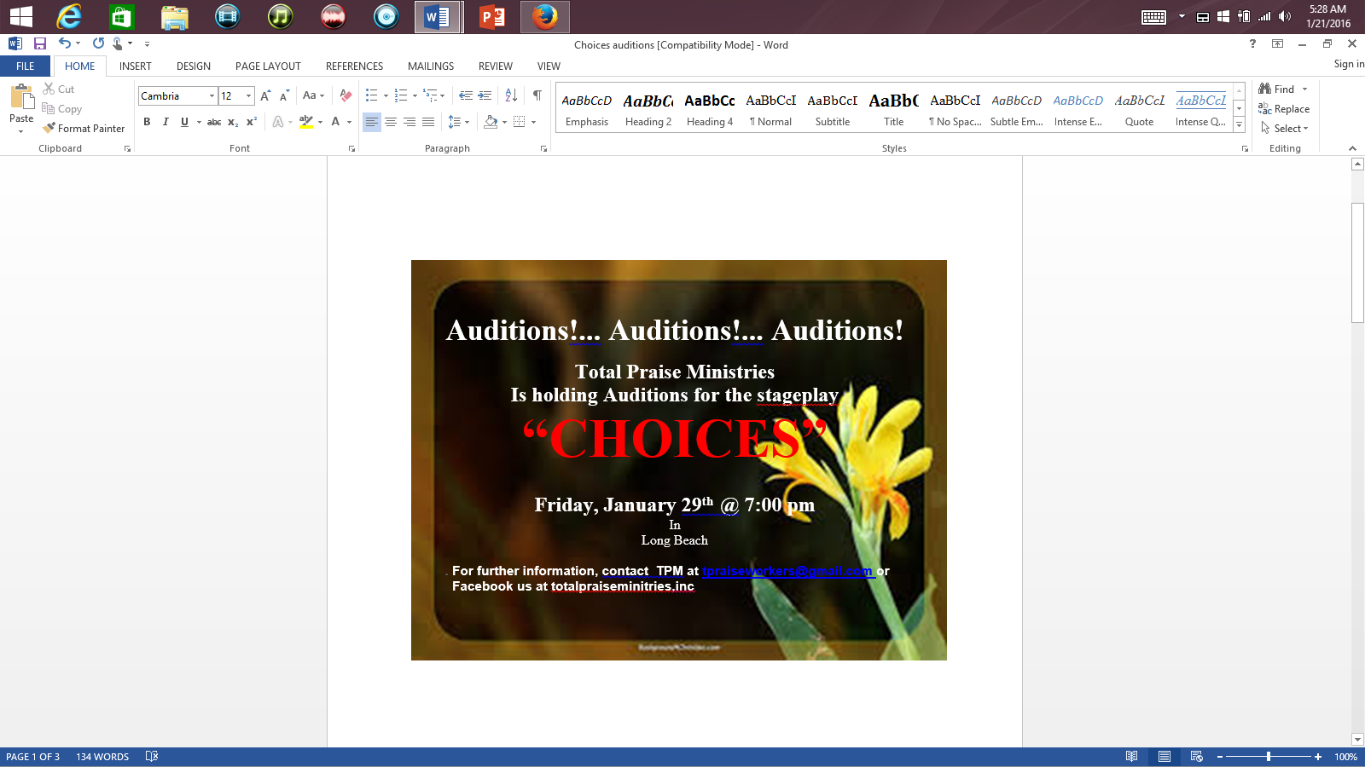

### Join us as we share the gospel in this heartwarming and inspiring story inspired by the poem Do You Believe in Easter?

We will audition for over **20 onstage roles** including teens and adults and a special audition for 4 children (K-5) non-speaking/one-liner roles. We also have numerous **backstage opportunities** for ages **6th grade through adult**. Auditions will be held Friday, **January 15th** at 7 PM and Saturday, **January 16th** at 9 AM. There is no need to prepare any materials. For further information, email [tpraiseworkers@gmail.com](mailto:tpraiseworkers@gmail.com) or facebook us at totalpraiseminitries,inc.



**Casting Call**

**Looking for a few good men**

Michael

African American man between the ages of 25 and 35 to play the lead role in our upcoming stage play “Choices” Must be able to sing

Dior

Man between 25 and 35 nice physique

African American, islander must be able to use an accent

Old Friend

Man between 25 and 35 nice physique

Old dude up in the Club

Man 50ish. Must be funny. Must be able to “old school” dance.

Doctor

Man 50 or better